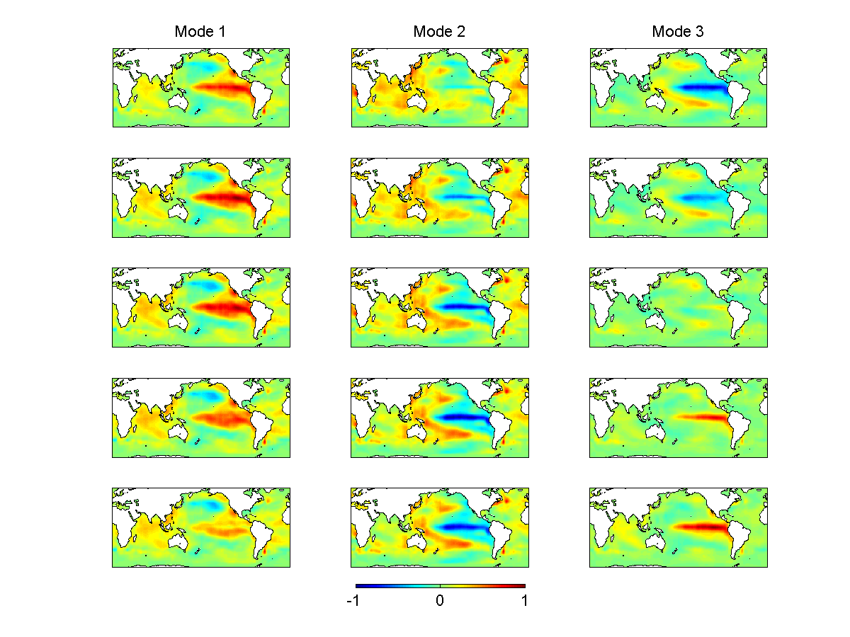

Figure S1. SST patterns of the first three EEOF modes from observations. Each mode is normalized and spans five seasons. Mode 1 is identified with a canonical ENSO, Mode 2 with a La Nina-like forced mode, and Mode 3 with a biannual ENSO.

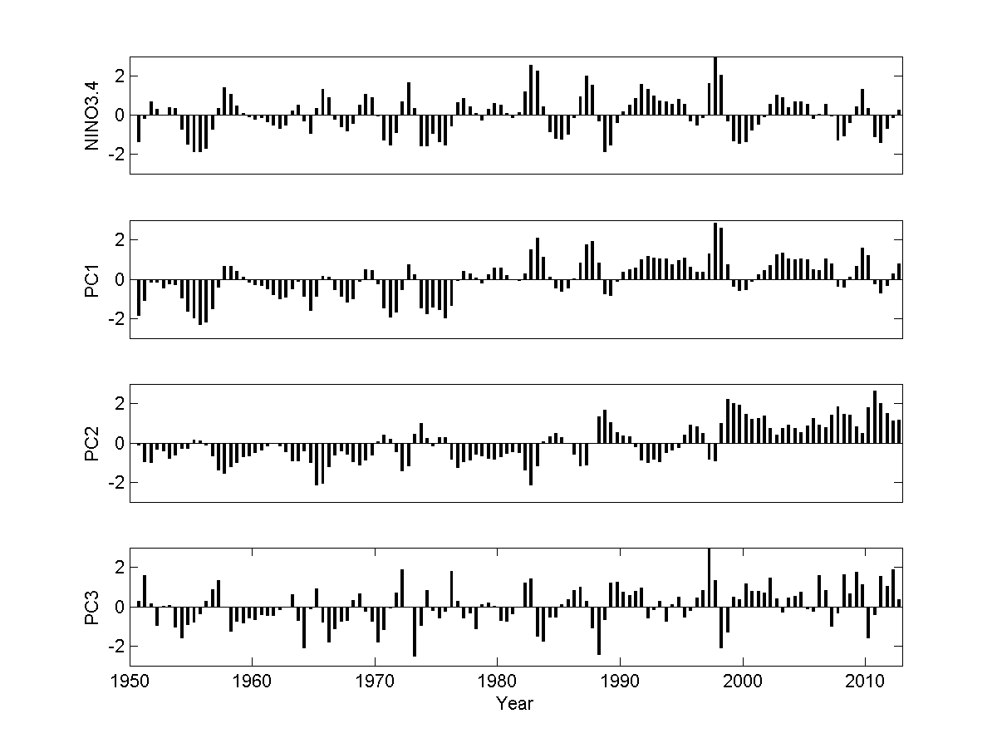

Figure S2. CT index (oC) and principal components (PCs) of the first three EEOF modes from observations. The PCs are normalized.

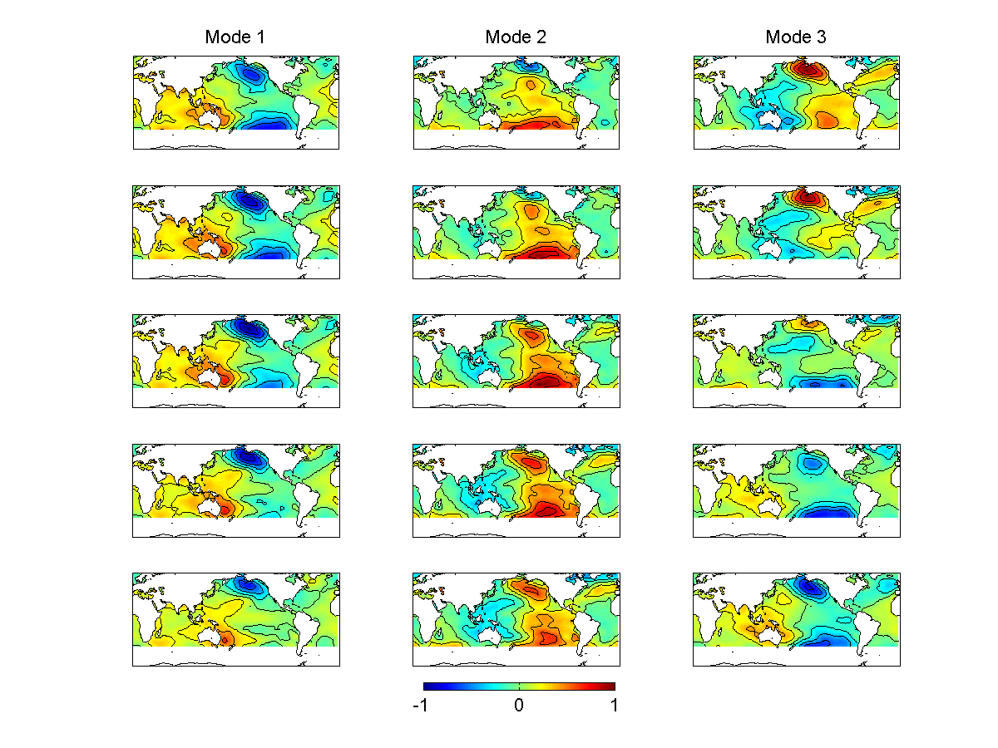

Figure S3. SLP patterns from regression with the first three EEOF modes from observations. Each mode is normalized and spans five seasons. The area south of 50oS is blocked because SLP is off the scale.

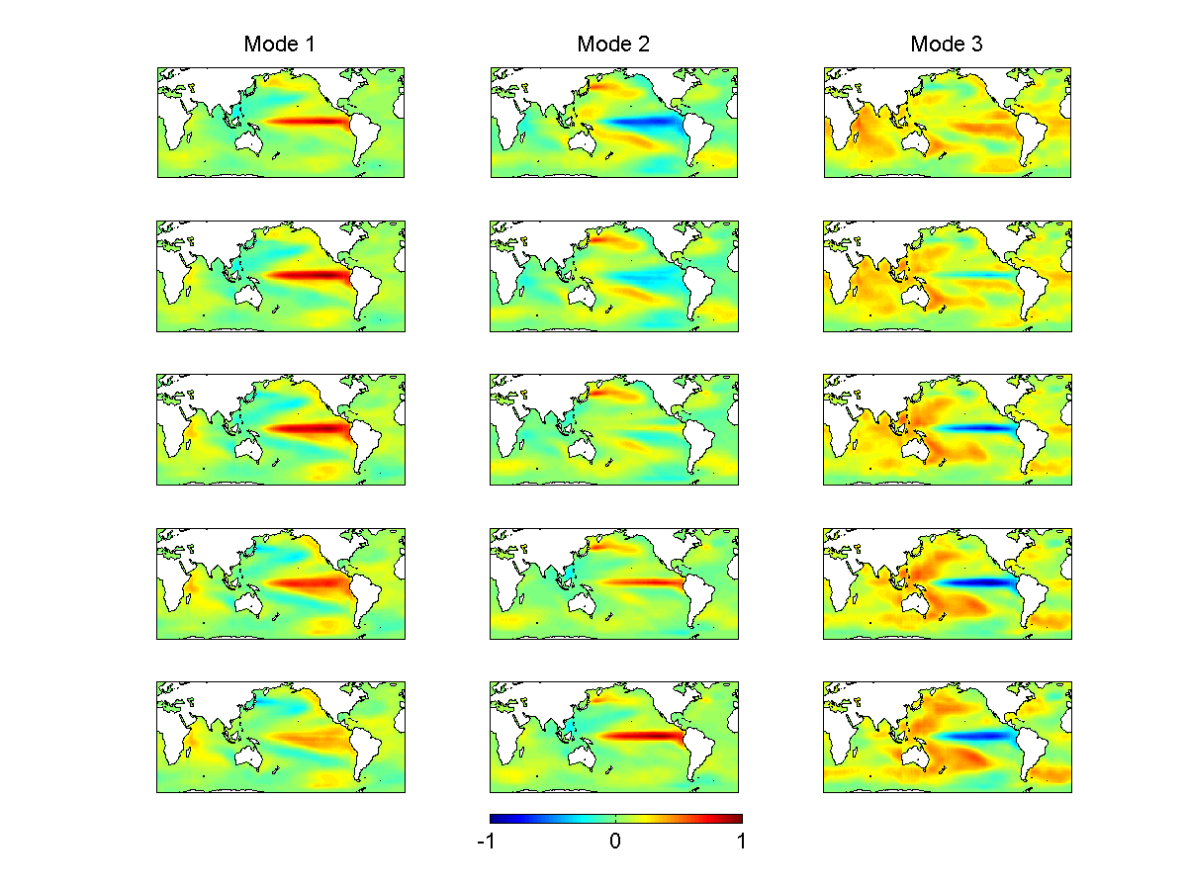

Figure S4. SST patterns of the first three EEOF modes from CCSM4. Each mode is normalized and spans five seasons. Mode 1 is identified with a canonical ENSO, Mode 2 with a biannual ENSO, and Mode 3 with a La Nina-like forced mode.

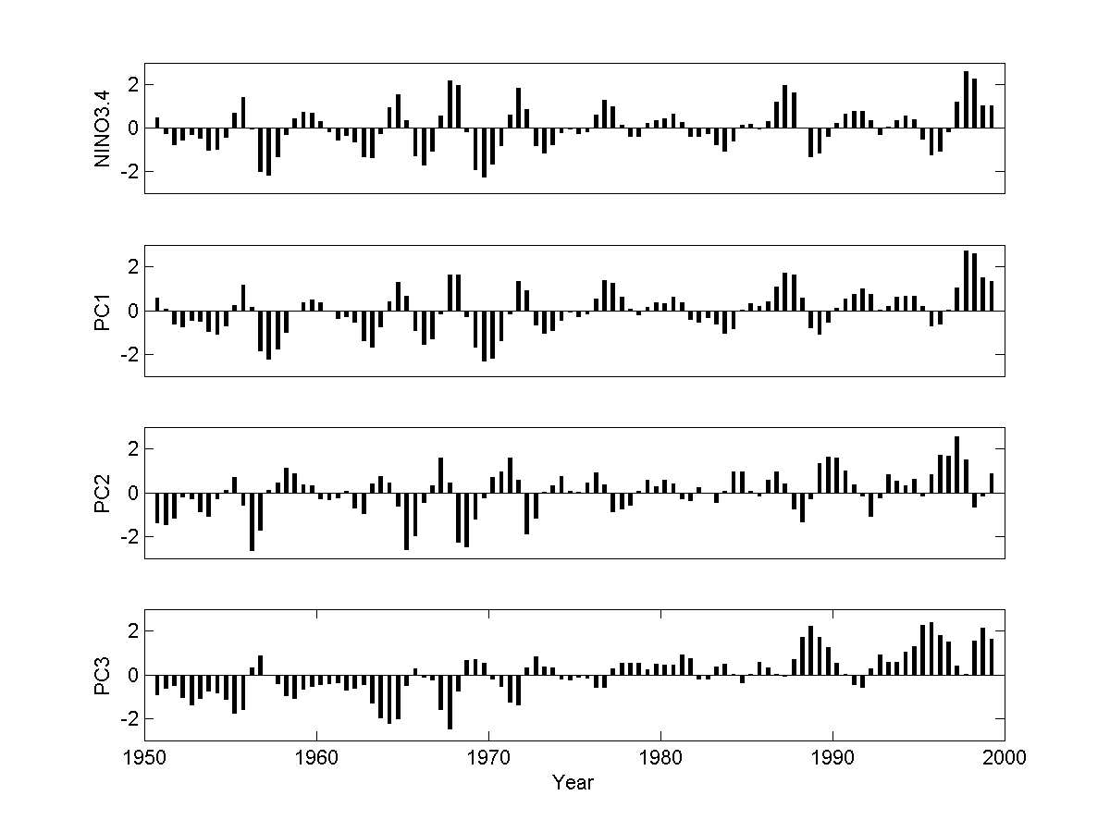

Figure S5. CT index (oC) and principal components (PCs) of the first three EEOF modes from CCSM4. The PCs are normalized.